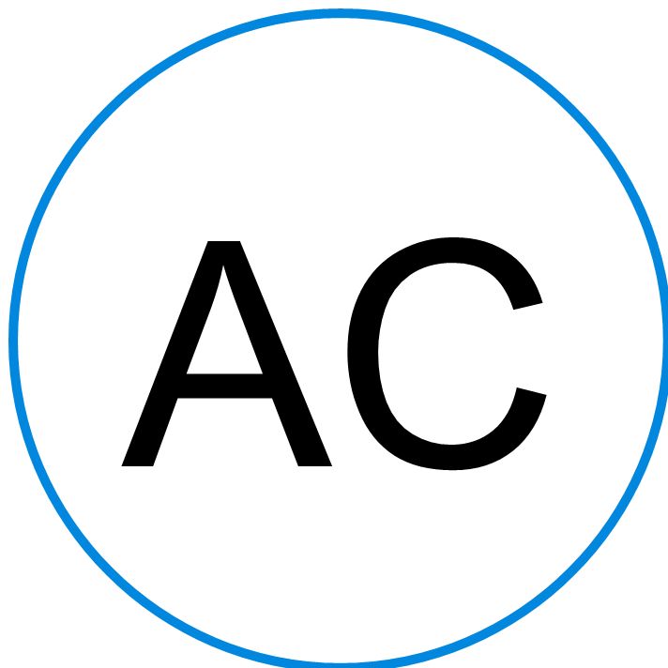 | Ana Maria Carolina        Belo Horizonte, 12356888 Brazil 123456789 anc@gmail.com

Professional Summary | Talented Cook with excellent experience in fast-paced kitchen environments. Clear communicator with team-oriented focus and advanced skills to effectively work with cashiers and kitchen staff to review and prepare orders. Qualified and hardworking with up-to-date food handling permit.

Skills | - Server Communication - Cutting Meat - Special Event Cooking - Cooking Method Accuracy

Work History | Line Cook 01/2019 to 01/2022  Fairmont Hotel | Belo Horizonte, Brazil  - Prepared multiple orders simultaneously during peak periods with high accuracy rate, maximizing customer satisfaction and repeat business.  - Set up and prepared cooking supplies and workstations during opening and closing to maximize productivity.  - Created identical dishes numerous times daily with consistent care, attention to detail and quality.  - Changed and sanitized cutting boards, benches and surfaces between tasks to avoid cross-contamination.

Education | High School Diploma 12/2017  Colégio Tiradentes, Belo Horizonte

Languages | English Upper intermediate (B2) Portuguese Bilingual or Proficient (C2)
.

